DREAM SMP TIMELINE
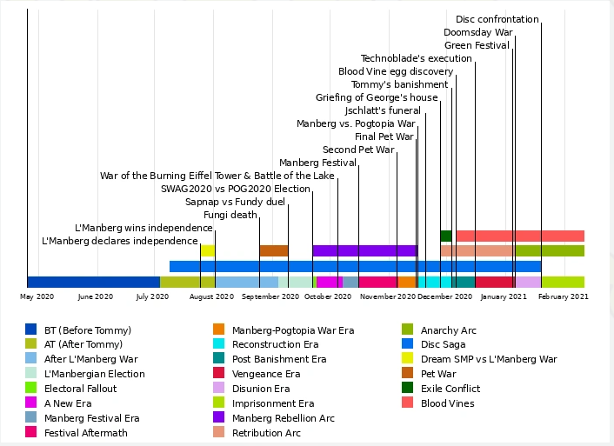
ERAS:
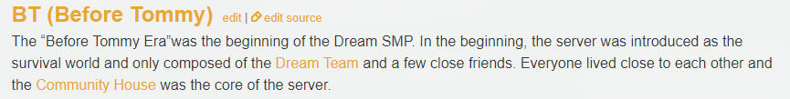
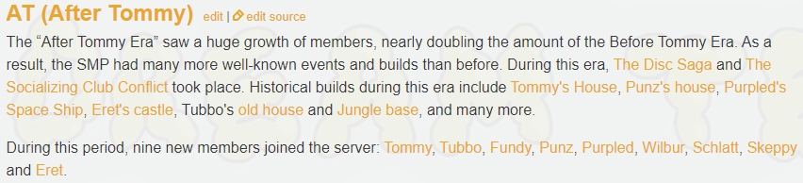
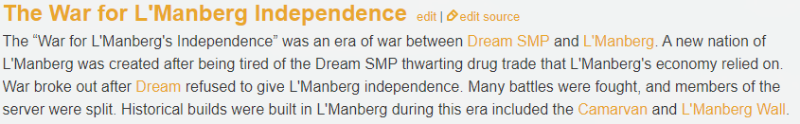
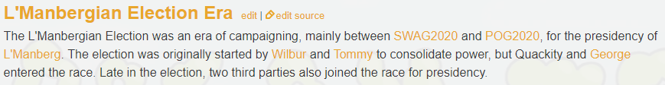
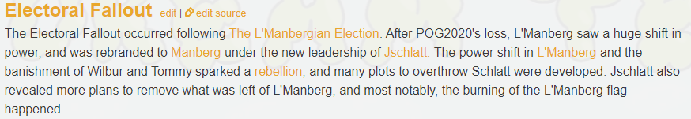
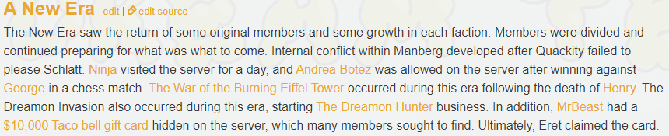
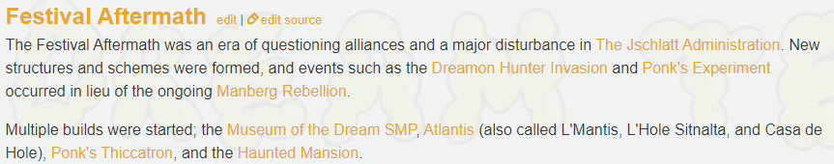
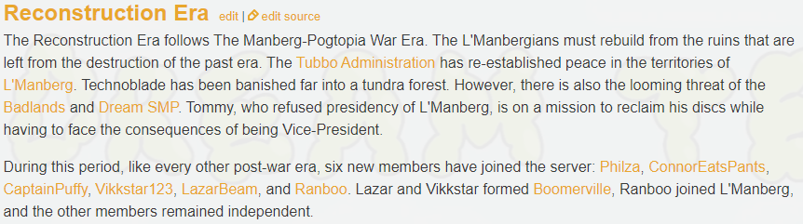
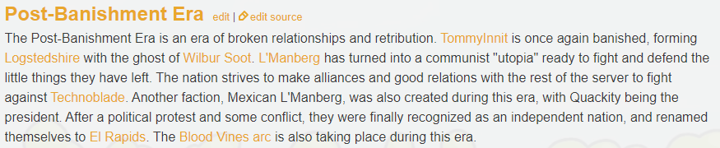
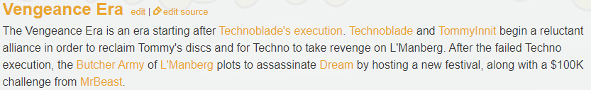
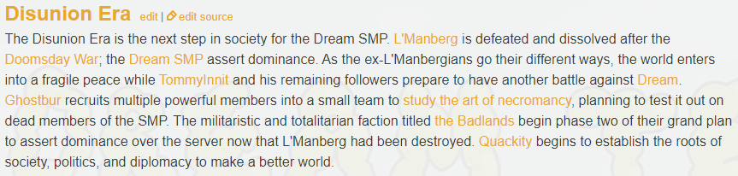
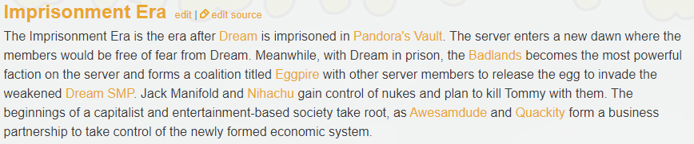
*screens from https://dreamteam.fandom.com/wiki/Dream_Team_Wiki*

